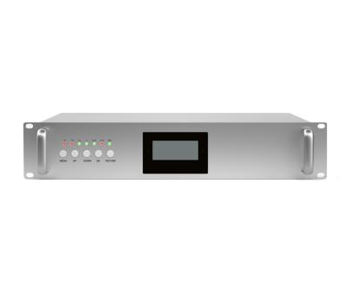
25dBm 900+1800+2100+2600Hz Repeater
Model: AT-25-GDWL26

Product Features:
- LCD display the input/output signal strength.
- Auto isolation detection.
- Improve any three mobile networks at the same time.
- Built-in Auto Gain Control (AGC)& Auto Level Control (ALC).
- OMS Lite for remote/local control and monitoring(Optional)

Working Schematic Diagram
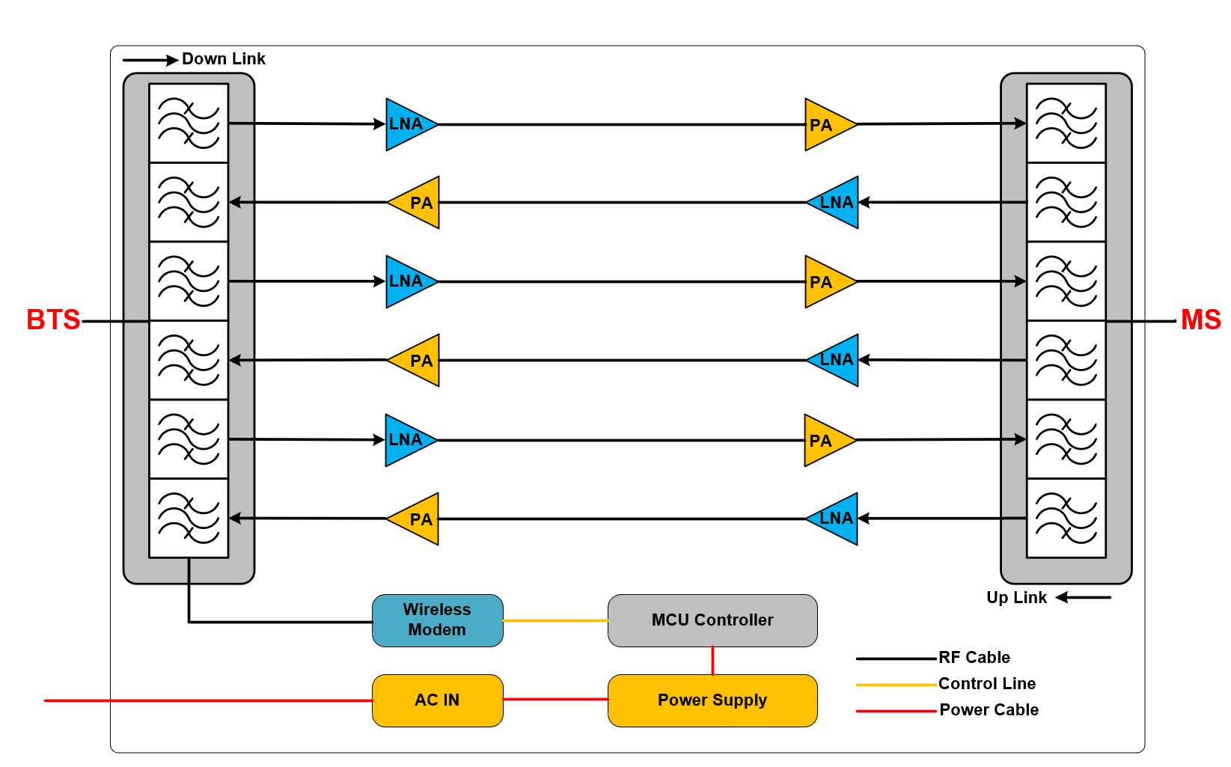

Application Scenario:


Technical Specifications:
P/N: AT-25-GDWL26 |  | B7 (2600MHz) |  | B8 (900MHz) | B3 (1800MHz) | B1(2100MHz)
Frequency Range | Uplink | 2500-2570MHz |  | 880-915MHz | 1710-1785MHz | 1920-1980MHz
Frequency Range | Downlink | 2620-2690MHz |  | 925-960MHz | 1805-1880MHz | 2110-2170MHz
Max. Gain | Uplink | 95±3 dB | 95±3 dB | 95±3 dB | 95±3 dB | 95±3 dB
Max. Gain | Downlink | 97±3 dB | 97±3 dB | 97±3 dB | 97±3 dB | 97±3 dB
Manual Gain Control |  | 31 dB in step of 1 dB
Automatic Gain Control |  | ≧ 20 dB
Gain Flatness (per sub-band) |  | ≦ ±3 dB (peak-to-peak)
Max. Input Power Without Damage |  | 0 dBm
Output Power | Uplink | 22±2 dBm
Output Power | Downlink | 25±2 dBm
Spurious Emission | 9KHz-1GHz | ≦ -36dBm
Spurious Emission | 1GHz-12.75GHz | ≦ -30dBm
ACRR | ±20/100MHz | ≦-36dBc/30KHz
ACRR | ±40/200MHz | ≦-40dBc/30KHz
EVM |  | ≦ 8%
Frequency Stability |  | ≦ ±0.01 ppm
Noise Figure |  | ≦ 6 dB
VSWR |  | ≦ 2
System Delay |  | ≦ 4.5 µs
RF Connector |  | N-Female
Impedance |  | 50 Ω
Power Supply |  | DC24V5A
Power Consumption |  | ≦ 200W
Dimensions |  | 480*350*88mm
Weight |  | ≦ 12kgs
IP Rating |  | IP40
Operating Temperature |  | -25 °C to 55 °C
Control & Monitoring | Remote | LTE Modem

Technical specification is subject to change without prior notice.

